Template for Preparation of Papers for IEEE Sponsored Conferences & Symposia（二号加粗20磅固定值行间距）

First A. Author, Second B. Author, Jr., and Third C. Author（小四，英文习惯）
（jilin university instrument science and engineering institute,changchun,130021）（五号斜体）

Abstract（小五斜体加粗）—These instructions give you guidelines for preparing papers for IEEE conferences. Use this document as a template if you are using Microsoft Word 6.0 or later. Otherwise, use this document as an instruction set. Instructions about final paper and figure submissions in this document are for IEEE journals; please use this document as a “template” to prepare your manuscript. For submission guidelines, follow instructions on paper submission system as well as the Conference website. Do not delete the blank line immediately above the abstract; it sets the footnote at the bottom of this column.（小五加粗）

I. Introduction（多倍行距，小型大写字母字体）
This（小型大写字母字体，无缩进） document is a template for Microsoft Word versions 6.0 or later. If you are reading a paper version of this document, please download the electronic file, ieeeconf_letter.dot (for letter sized paper: 8.5” x 11”) or ieeeconf_A4.dot (for A4 sized paper: 210mm x 297mm) and save to MS Word templates directory. The template to produce your conference paper is available at www.paperplaza.net/support/support.html. To create your own document, from within MS Word, open a new document using File | New then select ieeeconf_letter.dot (for letter sized paper) or ieeeconf_A4.dot (for A4 sized paper). All instructions beyond this point are from IEEE. Instructions about final paper and figure submissions in this document are for IEEE journals; please use this document as a “template” to prepare your manuscript. For submission guidelines, follow instructions on paper submission system as well as the Conference website.
If your paper is intended for a conference, please contact your conference editor concerning acceptable word processor formats for your particular conference.

II．Procedure for Paper Submission
A．Review Stage
Instructions about final paper and figure submissions in this document are for IEEE journals; please use this document as a “template” to prepare your manuscript. For submission guidelines, follow instructions on paper submission system as well as the Conference website. Please check with your editor on whether to submit your manuscript by hard copy or electronically for review. If hard copy, submit photocopies such that only one column appears per page. This will give your referees plenty of room to write comments. Send the number of copies specified by your editor (typically four). If submitted electronically, find out if your editor prefers submissions on disk or as e-mail attachments.
If you want to submit your file with one column electronically, please do the following:
--First, click on the View menu and choose Print Layout.
--Second, place your cursor in the first paragraph. Go to the Format menu, choose Columns, choose one column Layout, and choose “apply to whole document” from the dropdown menu.
--Third, click and drag the right margin bar to just over 4 inches in width.
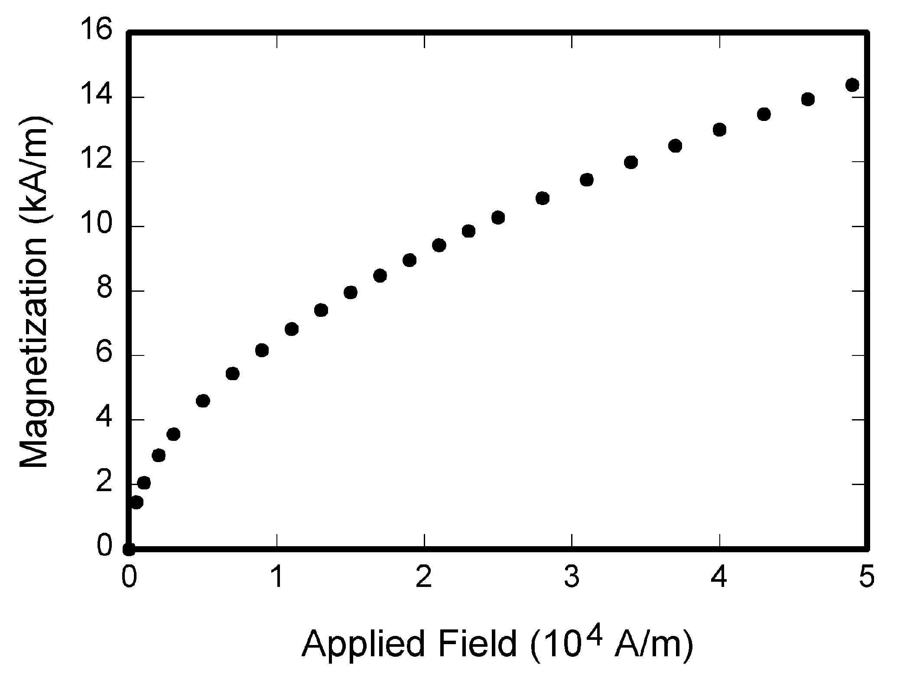
Fig. 1. Magnetization as a function of applied field.
TABLE I
Units for Magnetic Properties（小五）
Symbol | Quantity（小五） | Conversion from Gaussian and  CGS EMU to SI ª
Φ | magnetic flux | 1 Mx → 10⁻⁸ Wb = 10⁻⁸ V·s
B | magnetic flux density,  magnetic induction | 1 G → 10⁻⁴ T = 10⁻⁴ Wb/m²
H | magnetic field strength | 1 Oe → 10³/(4π) A/m
m | magnetic moment | 1 erg/G = 1 emu  → 10⁻³ A·m² = 10⁻³ J/T
M | magnetization | 1 erg/(G·cm³) = 1 emu/cm³  → 10³ A/m
4πM | magnetization | 1 G → 10³/(4π) A/m
σ | specific magnetization | 1 erg/(G·g) = 1 emu/g → 1 A·m²/kg
j | magnetic dipole  moment | 1 erg/G = 1 emu  → 4π × 10⁻¹⁰ Wb·m
J | magnetic polarization | 1 erg/(G·cm³) = 1 emu/cm³  → 4π × 10⁻⁴ T
χ, κ | susceptibility | 1 → 4π
χ_{ρ} | mass susceptibility | 1 cm³/g → 4π × 10⁻³ m³/kg
μ | permeability | 1 → 4π × 10⁻⁷ H/m  = 4π × 10⁻⁷ Wb/(A·m)
μ_{r} | relative permeability | μ → μ_{r}
w, W | energy density | 1 erg/cm³ → 10⁻¹ J/m³
N, D | demagnetizing factor | 1 → 1/(4π)
（表注六号）
B．References
Number citations consecutively in square brackets [1]. The sentence punctuation follows the brackets [2]. Multiple references [2], [3] are each numbered with separate brackets [1]–[3]. When citing a section in a book, please give the relevant page numbers [2]. In sentences, refer simply to the reference number, as in [3]. Do not use “Ref. [3]” or “reference [3]” except at the beginning of a sentence: “Reference [3] shows ... .” Unfortunately the IEEE document translator cannot handle automatic endnotes in Word; therefore, type the reference list at the end of the paper using the “References” style.
C．Equations
Number equations consecutively with equation numbers in parentheses flush with the right margin, as in (1). First use the equation editor to create the equation. Then select the “Equation” markup style. Press the tab key and write the equation number in parentheses. To make your equations more compact, you may use the solidus ( / ), the exp function, or appropriate exponents. Use parentheses to avoid ambiguities in denominators. Punctuate equations when they are part of a sentence, as in

$\begin{aligned}\int{ F(r,ϕ)} \text{dr} dϕ=[{σr}_{2} (2μ_{0})] \\ ⋅ \int{ \text{exp}}(−λ|z_{j}−z_{i}| ) λ^{−1} J_{1}(λ r_{2}) J_{0}(λ r_{i}) dλ \text{.}\end{aligned}$(1)

Be sure that the symbols in your equation have been defined before the equation appears or immediately following. Italicize symbols (T might refer to temperature, but T is the unit tesla). Refer to “(1),” not “Eq. (1)” or “equation (1),” except at the beginning of a sentence: “Equation (1) is ... .”

References
- G. O. Young, “Synthetic structure of industrial plastics (Book style with paper title and editor),” in Plastics, 2nd ed. vol. 3, J. Peters, Ed. New York: McGraw-Hill, 1964, pp. 15–64.
- W.-K. Chen, Linear Networks and Systems (Book style). Belmont, CA: Wadsworth, 1993, pp. 123–135.（自动编号，1.25倍的多倍行距，悬挂缩进0.63厘米）
注：
- 页面设置：上边距、下边距为：1.9cm，左边距、右边距为：1.9cm；页眉为：0.76cm，页角：0.76cm；
- 栏宽：23.32字符，栏间距2.13字符；
- 全文为新罗马五号，正文：单倍行距，首行缩进0.36厘米，并勾选自动调整左右缩进及对齐网格；
- 表和图的注释：六号居中。

